UNIVERSITY COLLEGE OF ENGINEERING, BIT (CAMPUS)
ANNA UNIVERSITY, TRICHY - 620024
DEPARTMENT OF INFORMATION TECHNOLOGY

BONAFIDE CERTIFICATE
This is to certify this Summer Internship project report “Web Development” is the bonafide work of ABDUL RAHMAN M(810023205312) has satisfactory completed the course of CS3711 - SUMMER INTERNSHIP for SEVENTH semester, B.TECH INFORMATION TECHNOLOGY during the academic year 2026-2027.
Faculty in charge Head of the Department

Submitted for the practical examination held on ……………………….
ABSTRACT
This report presents an account of a one-month internship undertaken at Fantasy Solution, Trichy, in the field of Web Development. The internship provided practical, hands-on exposure to the core technologies used in modern web design and development, including HTML, CSS, JavaScript, responsive and mobile-first design, typography, colour theory, navigation and information architecture, user experience (UX) and user interface (UI) design, CSS frameworks such as Bootstrap and Foundation, content management systems, website security, search engine optimization, web analytics, and database connectivity using JDBC.
The training was carried out over a structured 30-day schedule, progressing from foundational concepts to advanced topics such as performance optimization, accessibility, e-commerce design, and back-end database integration. Through this internship, practical skills in designing, developing, and evaluating functional and user-friendly websites were acquired, along with an understanding of professional workplace practices, teamwork, and time management. The report concludes with the key learning outcomes achieved and a reflection on the overall internship experience.

TABLE OF CONTENTS
ABSTRACT iii

LIST OF TABLES iv

CHAPTER 1 INTRODUCTION & OBJECTIVES 1
1.1 Profile of the Organization 1
1.2 Objectives of the Internship 2
1.3 Introduction 3
1.4 Scope of the Internship 4

CHAPTER 2 LITERATURE REVIEW / SYSTEM STUDY 5
2.1 Evaluation of Existing Frameworks 5
2.2 Problem Statement Identification 6
2.3 Proposed Solution / Methodology 7
2.4 Summary 8

CHAPTER 3 SYSTEM REQUIREMENTS & ARCHITECTURE 9
3.1 Hardware & Software Prerequisites 9
3.2 Architectural Design 10
3.3 Modular Breakdown 11
3.4 Development Workflow 12

CHAPTER 4 DEVELOPMENT AND RESULT ANALYSIS 13
4.1 System Implementation and Development (Day 1 - Day 30) 13
4.2 Result Analysis and Testing Parameters 28

CHAPTER 5 CONCLUSION 30

REFERENCES 31

APPENDIX A SAMPLE CODE SNIPPETS 32

OFFER LETTER………………………………………………………………33
CERTIFICATE OF COMPLETION OF INTERNSHIP……………………...34
COPY OF THE ATTENDANCE…………………………………...…………35
ANNEXURE………………………………………………………………..…36

CHAPTER 1
INTRODUCTION & OBJECTIVES

1.1 Profile of the Organization
Fantasy Solution, No. 16, Samnath Plazza, Third Floor, Near BG Naidu Sweets, Melapudur, Trichy - 1, is a leading IT solution and service provider offering innovative information-technology-enabled solutions to meet the demands arising from social transformation.
Focusing on software technology, Fantasy Solution provides industry solutions and product engineering solutions, related software products and platforms, and services through the seamless integration of software, manufacturing, and industrial management capabilities. Its services include real-time projects, web designing, web hosting, software development, and training, and the organization has participated in the formulation of several national IT standards and specifications.
The company offers software development in .NET, PHP and Java, web designing and development, mobile application development on Android, MATLAB-based image processing, Network Simulator (NS2), data mining tools, and big data development using R and Python.
Mission: To provide high-quality software development services, professional consulting and outsourcing; to make access to information easier and more secure; to improve communication and data exchange between businesses; to provide customers with value for money; and to provide employees with meaningful work and growth opportunities.
Vision: To be a leading IT company for consulting services and deployment of best-of-breed business solutions to top-tier domestic and international customers.

1.2 Objectives of the Internship
The internship at Fantasy Solution was undertaken with the following objectives:
- To gain practical exposure to the complete web development lifecycle, from planning and design to implementation and testing.
- To acquire hands-on proficiency in core front-end technologies — HTML, CSS, and JavaScript.
- To understand responsive and mobile-first design principles for building websites that work across devices.
- To learn user experience (UX) and user interface (UI) design practices for creating usable, accessible websites.
- To gain familiarity with CSS frameworks (Bootstrap, Foundation) and content management systems (WordPress, Joomla, Drupal).
- To understand website performance optimization, security practices, and search engine optimization (SEO).
- To gain exposure to back-end database connectivity using JDBC and to understand professional workplace practices.

1.3 Introduction
Professional development necessitates internships, which give students and recent graduates a chance to put their academic skills to use in practical situations. A typical internship offers practical experience in a particular subject of study and acts as a link between academic learning and implementation. With the help of these programs, interns are able to gain insight into their chosen career paths, develop vital skills, and comprehend workplace dynamics through exposure to the day-to-day operations of a business.
Participants in internships often take on a variety of tasks and responsibilities that advance their professional development. They participate in projects, work with a team to solve real business problems, and are supervised by experienced mentors. This report presents an overview of the goals, structure, and outcomes of the Web Development internship undertaken at Fantasy Solution, highlighting its value in preparing the intern for the professional workforce.

1.4 Scope of the Internship
The scope of this internship was primarily focused on front-end web development, covering the design, styling, responsiveness, and interactivity of web pages, while also including a foundational introduction to back-end database connectivity. The training was structured to build competence progressively — starting from the basic building blocks of the web (HTML and CSS), advancing through design methodology (UX/UI, accessibility, branding), moving on to modern development practices (frameworks, JavaScript, performance, security), and finally introducing supporting disciplines such as SEO, analytics, content management, and database connectivity.
The internship did not extend into advanced back-end frameworks, cloud deployment, or large-scale application architecture, as these were considered beyond the scope of a one-month, foundation-building training program. However, the breadth of topics covered provided a well-rounded introduction to the full web development lifecycle, equipping the intern with the practical skills and vocabulary needed to pursue more advanced, specialized learning in the future.

CHAPTER 2
LITERATURE REVIEW / SYSTEM STUDY

2.1 Evaluation of Existing Frameworks
During the course of the internship, several existing tools, languages, and frameworks used in modern web development were studied and evaluated. HTML and CSS were reviewed as the foundational languages for structuring and styling web content, while JavaScript was studied as the primary language for enabling interactivity and dynamic behaviour on web pages.
Popular CSS frameworks such as Bootstrap and Foundation were evaluated for their ability to speed up and standardize the design process through pre-built, responsive components. Content Management Systems, namely WordPress, Joomla, and Drupal, were also reviewed to understand how organizations manage and update website content without extensive manual coding. Additionally, website analytics tools such as Google Analytics were examined for their role in tracking user behaviour and website performance.

2.2 Problem Statement Identification
Through the study of existing web development practices, several common bottlenecks and gaps in typical website implementations were identified:
- Many websites lack proper responsive design, resulting in poor usability on mobile and tablet devices.
- Inconsistent typography, colour usage, and layout structures can reduce readability and visual appeal.
- Poor navigation design and unclear information architecture make websites difficult for users to browse.
- Insufficient attention to web accessibility excludes users with disabilities from effectively using a website.
- Unoptimized images, scripts, and stylesheets slow down page load times and hurt user experience.
- Weak security practices, such as the absence of HTTPS or protection against cross-site scripting (XSS), leave websites vulnerable to attacks.
- Lack of search engine optimization reduces a website's visibility and organic reach.

2.3 Proposed Solution / Methodology
To address the gaps identified above, a structured, incremental learning and implementation methodology was followed throughout the internship, moving from foundational concepts to advanced, real-world practices:
- Building a strong foundation in HTML and CSS, including the CSS box model and positioning techniques.
- Applying responsive web design and media queries to ensure cross-device compatibility.
- Improving visual design through typography, colour theory, and imagery optimization.
- Designing intuitive navigation, UX flows, and UI components using established design patterns.
- Adopting CSS frameworks (Bootstrap, Foundation) for faster, standardized, and responsive layouts.
- Enhancing interactivity using JavaScript, including DOM manipulation and event handling.
- Optimizing performance through caching, minification, and image compression.
- Strengthening security using HTTPS, XSS prevention, and regular security audits.
- Applying SEO techniques and analytics to improve visibility and support data-driven design decisions.
- Integrating back-end database connectivity using JDBC for dynamic, data-driven web functionality.

2.4 Summary
The literature and system study phase of the internship established a clear picture of both the tools available for modern web development and the common shortcomings found in real-world websites. This understanding directly shaped the structured, incremental methodology followed during the remainder of the internship, ensuring that each concept learned was tied to a specific, identifiable improvement over typical existing practice — whether in responsiveness, accessibility, performance, security, or discoverability.

CHAPTER 3
SYSTEM REQUIREMENTS & ARCHITECTURE

3.1 Hardware & Software Prerequisites
The following hardware and software were used during the development and testing of the web development tasks carried out in this internship:
Requirement | Details
Operating System | Windows 10 / 11 (or equivalent)
RAM | 4 GB minimum (8 GB recommended)
Code Editor / IDE | Visual Studio Code / Sublime Text
Front-end Languages | HTML5, CSS3, JavaScript (ES6)
CSS Frameworks | Bootstrap, Foundation
Content Management Systems | WordPress, Joomla, Drupal
Database Connectivity | Java Database Connectivity (JDBC), SQL
Browser | Google Chrome / Mozilla Firefox (with Developer Tools)
Analytic & Testing Tools | Google Analytic, browser accessibility & performance audit tools
Version Control | Git

3.2 Architectural Design
The web applications developed during the internship followed a standard three-tier web architecture, consisting of a presentation layer, a logic layer, and a data layer:
- Presentation Layer (Front-end): Built using HTML, CSS, and JavaScript, responsible for the visual layout, styling, responsiveness, and user interactions.
- Logic Layer (Application Layer): Handles client-side interactivity (via JavaScript/DOM manipulation) and, where applicable, server-side processing of requests.
- Data Layer (Back-end): Manages storage and retrieval of data using relational databases, accessed through JDBC for CRUD (Create, Read, Update, Delete) operations.
The general flow of a request begins at the user's browser, which sends a request to the web server; the server processes the request (invoking the application logic as needed), retrieves or updates data from the database layer, and returns a rendered response back to the browser for display.
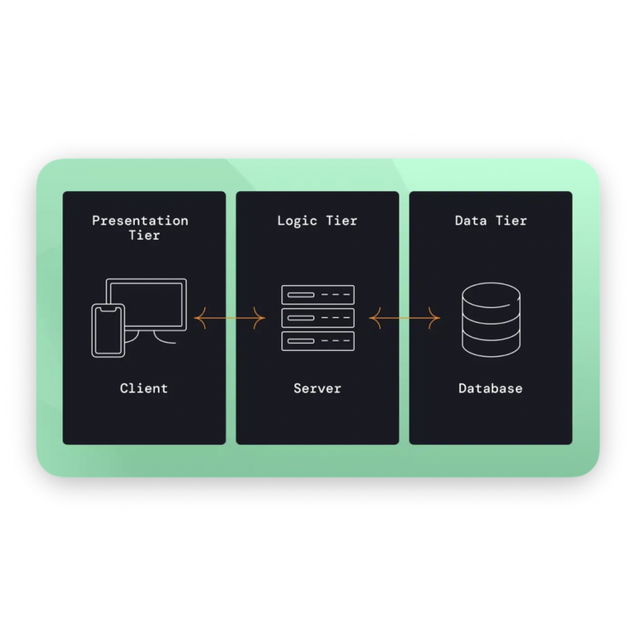
Figure 3.1: Three-Tier Web Architecture (Browser → Presentation → Logic → Data)

3.3 Modular Breakdown
The internship work can be broadly organized into the following functional modules:
- Module 1 — Structure & Styling: HTML page structuring, CSS box model, positioning, and layout.
- Module 2 — Responsive & Mobile-first Design: Media queries, fluid layouts, mobile-friendly design.
- Module 3 — Visual Design: Typography, colour theory, imagery, and branding/visual identity.
- Module 4 — Navigation, UX & UI: Navigation menus, wireframing, prototyping, and UI component design.
- Module 5 — Frameworks & Layouts: Grid systems and CSS frameworks (Bootstrap, Foundation).
- Module 6 — Interactivity: JavaScript fundamentals, DOM manipulation, and event handling.
- Module 7 — Optimization, Security & SEO: Performance optimization, HTTPS/XSS prevention, and SEO.
- Module 8 — Content Management & Analytics: CMS platforms and website analytics/tracking.
- Module 9 — Database Connectivity: JDBC-based connection between the web application and a relational database.
Figure 3.2: Modular Breakdown of Internship Work (Modules 1-9)

3.4 Development Workflow
Each module of the internship followed a consistent, disciplined development workflow, modelled on practices used in professional web development teams. This workflow ensured that the work carried out each day was purposeful, testable, and cumulative.
- Plan: Review the day's topic, define a small, concrete exercise or sample page to build.
- Build: Implement the exercise using the tools and techniques introduced for that topic.
- Test: Verify the result in the browser, including cross-checking on multiple simulated screen sizes where relevant.
- Review: Compare the result against the day's learning objective and note any issues or improvements for next time.
- Document: Record the activities performed and outcomes achieved, forming the basis of the day-wise log presented in Chapter 4.
This plan-build-test-review-document cycle, repeated across all 30 days, ensured steady, verifiable progress and produced the structured activity log and learning outcomes presented in the following chapter.

CHAPTER 4
DEVELOPMENT AND RESULT ANALYSIS

4.1 System Implementation and Development
The internship was carried out over a structured 30-day schedule, with each day building on the concepts and skills acquired previously — progressing from front-end fundamentals to advanced, real-world web development practices. A summary of the day-wise schedule is presented in Table 4.1, followed by a detailed account of the activities performed, and the outcomes achieved, on each day.
Table 4.1: Day-wise Internship Activity Log (Summary)
Day | Activities Performed
1 | Learned the fundamentals of web development and its importance in creating effective websites. Studied JavaScript, HTML, CSS, and other essential elements of web pages, and set up the development environment.
2 | Learned the foundations of HTML — arranging content using headings, paragraphs, lists, and links. Created a simple HTML page viewable in a web browser.
3 | Studied CSS and its use in web design, including selectors, attributes, and values used to style HTML elements.
4 | Studied the CSS box model in depth — padding, borders, margins, and content — along with positioning techniques for arranging page elements.
5 | Focused on responsive web design — creating layouts that work across various screens and devices using media queries, and building mobile-friendly, accessible websites.
6 | Studied typography in web design — font families, styles, weights, and widths; including web-safe and custom fonts, and improving readability through spacing and alignment.
7 | Studied colour in web design — colour models (RGB, hexadecimal), applying colour via CSS, and colour psychology and accessibility considerations.
8 | Studied the importance of images in website design — file-size reduction, web-friendly image techniques, and adding/positioning images using the HTML img element and CSS.
9 | Focused on navigation design — types of navigation menus (vertical, horizontal) and building responsive, user-friendly navigation systems.
10 | Began studying User Experience (UX) design principles for building visually appealing, user-friendly websites, along with wireframing and prototyping tools.
11 | Studied User Interface (UI) design — UI components such as buttons, forms, and icons, and UI design patterns and best practices.
12 | Learned about web accessibility and its importance in inclusive web design, along with tools for website evaluation and accessibility testing.
13 | Focused on website layouts — grid layouts and responsive grid systems using CSS frameworks such as Bootstrap, and techniques for balanced page layouts.
14 | Studied CSS frameworks in depth, including Bootstrap and Foundation, and their responsive design tools for streamlining web design.
15 | Studied interaction design — building engaging user experiences with HTML, CSS, and JavaScript, including sliders, forms, buttons, transitions, and animations.
16 | Studied web design optimization techniques — caching strategies, image optimization, and minification of CSS/JavaScript files to improve performance and load times.
17 | Began learning JavaScript fundamentals — syntax, variables, data types, operators, conditionals, loops, functions, and scope.
18 | Studied responsive images, event handling, and DOM manipulation for building interactive websites.
19 | Studied User-Centered Design (UCD) — conducting user research, gathering feedback, and applying iterative design and usability testing.
20 | Studied current web design trends and best practices — minimalist and flat design, micro-interactions, hierarchy, visual balance, and typography.
21 | Studied mobile-first design — designing for mobile devices first, screen-size optimization, and touch-friendly interfaces.
22 | Studied information architecture — organizing website content using sitemaps, navigation menus, and classification systems.
23 | Studied branding and visual identity in web design — applying logos, colour schemes, and typography for a cohesive brand identity.
24 | Studied usability testing techniques — user testing, heatmaps, analytics, and gathering feedback for data-driven design decisions.
25 | Studied web design for e-commerce — visually appealing product pages, streamlined checkout processes, and building customer trust.
26 | Studied Search Engine Optimization (SEO) — keyword research, on-page SEO, and link-building strategies.
27 | Studied website analytics and tracking — configuring and analyzing data using tools such as Google Analytics for data-driven decisions.
28 | Studied website security — HTTPS configuration, preventing cross-site scripting (XSS), and conducting regular security audits.
29 | Studied Content Management Systems (CMS) — WordPress, Joomla, and Drupal, and techniques to customize CMS functionality.
30 | Studied database connectivity using Java Database Connectivity (JDBC) — running SQL queries, managing transactions, and performing CRUD operations.

Day 1: Orientation and Web Development Fundamentals
The first day of the internship began with an orientation session at Fantasy Solution, where the overall structure of the training program, the tools to be used, and the expectations for the month were explained. The importance of web development as a discipline was introduced, along with an overview of how websites are built, hosted, and maintained in a professional environment.
By the end of the day, a clear roadmap for the remainder of the internship had been formed, and the basic development environment was fully functional and ready for use in subsequent tasks.
Key Takeaways:
- Development environment (editor, browser, Git) successfully configured.
- Understood the relationship between HTML, CSS, and JavaScript.

Day 2: HTML Fundamentals — Structuring Web Content
Day two focused on HyperText Markup Language (HTML), the backbone of every web page. The session began with an explanation of the document object model (DOM) and how browsers parse HTML tags into a tree of elements that can later be styled and manipulated.
A simple multi-section HTML page was created and successfully viewed in a browser, demonstrating a working understanding of page structure, semantic tagging, and hyperlink navigation.
Key Takeaways:
- Built a complete semantic HTML page from scratch.
- Understood the DOM tree and how browsers render markup.

Day 3: Introduction to CSS — Styling Web Pages
The third day introduced Cascading Style Sheets (CSS), the language used to control the visual presentation of HTML content. The concept of selectors — element, class, ID, and attribute selectors — was studied in detail, along with the rules that determine specificity and the cascade.
The exercises reinforced how CSS selectors target specific elements and how style rules cascade and override one another, which is essential knowledge for building consistent, maintainable designs.
Key Takeaways:
- Understood selectors, specificity, and the CSS cascade.
- Linked external stylesheets and applied core styling properties.

Day 4: The CSS Box Model and Positioning
Day four covered the CSS box model in depth — the concept that every HTML element is treated as a rectangular box composed of content, padding, border, and margin. Understanding how these layers interact is fundamental to controlling spacing and layout precisely.
By combining box-model properties with positioning techniques, several small layout exercises were completed, giving a much clearer picture of how complex page layouts are constructed from simple building blocks.
Key Takeaways:
- Mastered the content-padding-border-margin box model.
- Practiced static, relative, absolute, and fixed positioning.

Day 5: Responsive Web Design and Media Queries
With growing use of mobile devices, responsive design has become essential to modern web development. Day five focused on techniques for building layouts that adapt gracefully to different screen sizes, from small phones to large desktop monitors.
The day's work resulted in a working responsive page that displayed correctly on simulated mobile, tablet, and desktop viewports using the browser's device toolbar.
Key Takeaways:
- Implemented media queries for multiple screen breakpoints.
- Practiced fluid, mobile-first layout techniques.

Day 6: Typography in Web Design
Typography plays a major role in readability and visual identity, and day six was dedicated to understanding how fonts are chosen and applied on the web. Topics covered included font families, font weights and styles, line height, letter spacing, and the difference between web-safe fonts and custom web fonts.
The exercises resulted in a noticeably more polished and readable page compared to earlier default-font versions, highlighting the practical value of thoughtful typography choices.
Key Takeaways:
- Learned to pair and import custom web fonts.
- Applied line-height and letter-spacing for improved readability.

Day 7: Colour Theory and Application in Web Design
Day seven focused on the role of colour in web design, beginning with an overview of colour models used on the web, including RGB and hexadecimal notation, and how these values are applied through CSS properties such as colour and background-colour.
A sample colour palette was created and applied consistently across a demo page, resulting in a more visually cohesive and accessible design.
Key Takeaways:
- Understood RGB and hexadecimal colour models.
- Built a consistent colour palette for a sample page.

Day 8: Working with Images on the Web
The eighth day addressed the correct use of images in web design. The session began with a discussion of common image formats (JPEG, PNG, SVG, WebP) and the trade-offs between file size and visual quality for each.
By the end of the session, a gallery-style page had been built that loaded efficiently while maintaining good visual quality across screen sizes.
Key Takeaways:
- Learned appropriate use cases for JPEG, PNG, SVG, and WebP.
- Implemented responsive images using CSS.

Day 9: Navigation Design and Menu Systems
Good navigation is central to a usable website, and day nine focused on designing and building navigation menus. Both horizontal top-navigation bars and vertical sidebar-style menus were studied, along with their appropriate use cases.
Testing across different screen sizes confirmed that the navigation adapted correctly, remaining easy to use on both desktop and mobile layouts.
Key Takeaways:
- Built a responsive navigation bar using flexbox.
- Implemented a collapsible mobile menu pattern.

Day 10: Introduction to User Experience (UX) Design
Day ten shifted focus from purely visual and structural concerns to the broader discipline of User Experience (UX) design — designing products around the needs, behaviours, and goals of real users.
A simple wireframe was sketched for a sample landing page, translating abstract requirements into a concrete visual plan that could guide subsequent development.
Key Takeaways:
- Understood core UX concepts such as personas and user journeys.
- Practiced low-fidelity wireframing for page planning.

Day 11: User Interface (UI) Design Components
Building on the previous day's UX foundation, day eleven focused on User Interface (UI) design — the visual and interactive components users directly engage with, such as buttons, forms, icons, and cards.
A small set of reusable UI components was built and styled, forming a mini component library that could be reused across multiple pages.
Key Takeaways:
- Designed reusable UI components (buttons, cards, forms).
- Applied consistent interaction states across components.

Day 12: Web Accessibility Principles
Day twelve was dedicated to web accessibility — the practice of designing websites that can be used by people with a wide range of abilities and disabilities. The session began with an overview of the Web Content Accessibility Guidelines (WCAG) and their four core principles.
A sample page was audited using a browser accessibility checker, and several issues (missing alt attributes and low-contrast text) were identified and corrected, resulting in a more inclusive final page.
Key Takeaways:
- Learned the WCAG accessibility principles.
- Applied semantic HTML and alt text for screen readers.

Day 13: Website Layouts and Grid Systems
Day thirteen focused on building structured page layouts using modern CSS layout systems, particularly CSS Grid. The differences between Flexbox (one-dimensional layout) and Grid (two-dimensional layout) were discussed, along with guidance on choosing the right tool for a given layout problem.
The exercise reinforced how professional websites achieve balanced, well-aligned layouts, and prepared the ground for working with pre-built frameworks in the following sessions.
Key Takeaways:
- Understood the difference between Flexbox and CSS Grid.
- Built a custom 12-column responsive grid layout.

Day 14: CSS Frameworks — Bootstrap and Foundation
Building on the previous day's grid knowledge, day fourteen introduced popular CSS frameworks, primarily Bootstrap and, more briefly, Foundation. These frameworks provide pre-built, tested components and a responsive grid system that significantly speed up development.
The exercise highlighted the trade-off between the speed and consistency offered by frameworks and the additional file size and reduced design flexibility that can come with using them.
Key Takeaways:
- Integrated Bootstrap into a project via CDN.
- Rebuilt a page using framework grid and components.

Day 15: Interaction Design with HTML, CSS, and JavaScript
Day fifteen focused on interaction design — the small but impactful details that make a website feel responsive and engaging, such as hover effects, button animations, sliders, and smooth transitions.
Testing confirmed that the animations and slider worked smoothly across the browser used for development, and the exercise illustrated how JavaScript and CSS can be combined for engaging interactive elements.
Key Takeaways:
- Implemented CSS transitions and hover animations.
- Built a functional JavaScript-powered image slider.

Day 16: Web Performance Optimization
Day sixteen addressed website performance — an important factor in both user experience and search engine ranking. The session began with an overview of what determines page load speed, including file sizes, the number of HTTP requests, and render-blocking resources.
The measured results showed a clear improvement in page load time after optimization, demonstrating the direct, practical value of these techniques.
Key Takeaways:
- Minified CSS/JavaScript and compressed images.
- Measured load-time improvements using developer tools.

Day 17: JavaScript Fundamentals — Syntax and Data Types
Day seventeen marked the beginning of a deeper study of JavaScript, the language responsible for interactivity on the web. The session covered core syntax, including variable declarations (var, let, const), primitive data types, and basic operators.
By the end of the day, several small standalone JavaScript programs had been written and tested in the browser console, building confidence with the language's basic building blocks.
Key Takeaways:
- Practiced variables, data types, and operators in JavaScript.
- Wrote conditionals, loops, and functions.

Day 18: DOM Manipulation, Events, and Responsive Images
Day eighteen focused on connecting JavaScript to the HTML page through the Document Object Model (DOM). Methods for selecting elements (getElementById, querySelector) and modifying their content, attributes, and styles were studied and practiced.
A small interactive to-do list style page was built, demonstrating DOM selection, event handling, and dynamic content updates working together.
Key Takeaways:
- Selected and modified DOM elements with JavaScript.
- Implemented click and form event handlers.

Day 19: User-Centered Design and Usability Feedback
Day nineteen returned to design methodology, focusing on User-Centered Design (UCD) — an iterative process in which real user needs and feedback drive design decisions rather than assumptions alone.
The feedback gathered highlighted a few small usability issues, which were noted for improvement, reinforcing the value of testing designs with real users rather than relying solely on personal judgement.
Key Takeaways:
- Studied the stages of the User-Centered Design process.
- Conducted an informal usability review of a sample page.

Day 20: Current Web Design Trends and Best Practices
Day twenty involved a survey of current web design trends and industry best practices, including minimalist and flat design aesthetics, the use of whitespace for visual hierarchy, and subtle micro-interactions that provide feedback to users.
This review-based session helped connect the individual techniques learned so far into a broader understanding of what makes a website feel modern and professional.
Key Takeaways:
- Studied minimalist, flat design, and micro-interaction trends.
- Critiqued live websites for hierarchy and balance.

Day 21: Mobile-First Design Approach
Day twenty-one focused specifically on the mobile-first design philosophy — designing for the smallest screen first and progressively enhancing the layout for larger screens, rather than the reverse.
The resulting page performed well across all tested screen sizes and reinforced why mobile-first has become the standard approach in modern responsive design.
Key Takeaways:
- Rebuilt a page using a true mobile-first workflow.
- Applied touch-friendly sizing for interactive elements.

Day 22: Information Architecture and Content Organization
Day twenty-two addressed information architecture (IA) — the practice of organizing, structuring, and labelling website content so that users can find information easily and efficiently.
The resulting sitemap provided a clear blueprint for how the website's pages and navigation should be structured before any visual design work began.
Key Takeaways:
- Created a sitemap for a multi-page website.
- Learned card-sorting as an IA research technique.

Day 23: Branding and Visual Identity in Web Design
Day twenty-three focused on how branding elements — logo, colour palette, and typography — are consistently applied across a website to build a recognizable visual identity.
The exercise demonstrated how a well-defined style guide makes it significantly easier to maintain consistency as a website grows in size and complexity.
Key Takeaways:
- Created a basic brand style guide (colours, fonts, logo usage).
- Applied consistent branding across multiple pages.

Day 24: Usability Testing Techniques
Day twenty-four expanded on usability testing methods, including moderated user testing, heatmap analysis, and the use of analytics data to understand how real users interact with a page.
The observations revealed a navigation label that was not immediately clear to first-time users, an issue that would have been difficult to identify without direct observation, underscoring the value of usability testing even in its simplest form.
Key Takeaways:
- Learned heatmap and analytics-based usability techniques.
- Conducted a simplified moderated usability test.

Day 25: Web Design for E-Commerce
Day twenty-five focused on the specific design considerations that apply to e-commerce websites, where the primary goal is to guide users smoothly from product discovery to a completed purchase.
A sample product page and cart summary were designed, applying these principles to create a clear and trustworthy shopping experience.
Key Takeaways:
- Studied core e-commerce UX patterns.
- Designed a sample product page and cart summary.

Day 26: Search Engine Optimization (SEO) Fundamentals
Day twenty-six introduced Search Engine Optimization (SEO) — the set of practices used to improve a website's visibility in search engine results. The session covered on-page SEO factors such as page titles, meta descriptions, header tag hierarchy, and descriptive URL structures.
The exercise resulted in a sample page with properly optimized titles, meta tags, and heading structure, following current on-page SEO best practices.
Key Takeaways:
- Practiced keyword research using online SEO tools.
- Optimized page titles, meta tags, and heading structure.

Day 27: Website Analytics and Tracking
Day twenty-seven focused on measuring website performance and user behaviour using analytics tools, primarily Google Analytics. The session covered how tracking codes are installed on a website and what key metrics — such as page views, bounce rate, and session duration — reveal about user engagement.
This session tied together many of the design and UX concepts studied earlier by showing how their real-world effectiveness can be measured objectively using data.
Key Takeaways:
- Understood key website analytics metrics.
- Practiced interpreting a sample analytics dashboard.

Day 28: Website Security Fundamentals
Day twenty-eight addressed website security, beginning with the importance of HTTPS and SSL/TLS certificates for encrypting data transmitted between a browser and a server, and how this affects both user trust and search engine ranking.
A checklist of basic security best practices was compiled, providing a practical reference for ensuring reasonable security hygiene on future web projects.
Key Takeaways:
- Understood the role of HTTPS/SSL in web security.
- Learned the basics of XSS and input validation.

Day 29: Content Management Systems (CMS)
Day twenty-nine introduced Content Management Systems (CMS), software platforms that allow non-technical users to create and manage website content without writing code directly. WordPress, Joomla, and Drupal were compared in terms of ease of use, flexibility, and typical use cases.
The session highlighted the trade-offs between hand-coded websites and CMS-driven sites, particularly around long-term maintainability and the involvement of non-developer content editors.
Key Takeaways:
- Compared WordPress, Joomla, and Drupal.
- Customized a page using the WordPress block editor.

Day 30: Database Connectivity Using JDBC
The final day of the internship shifted focus to the back-end, introducing Java Database Connectivity (JDBC) as a means of connecting a web application to a relational database. The JDBC architecture — drivers, connections, statements, and result sets — was explained conceptually.
This concluding session tied together the internship's front-end and design-focused learning with a foundational introduction to back-end data handling, providing a well-rounded overview of the full web development stack.
Key Takeaways:
- Understood the JDBC connection architecture.
- Executed CRUD operations against a MySQL database.

4.2 Result Analysis and Testing Parameters
The internship provided a rich and varied learning experience, resulting in the following key learning outcomes and skills, which were evaluated against the objectives set out in Chapter 1:
- Gained a solid grasp of the fundamental concepts and tools used in web development, and improved technical skills through practical experience with industry-standard software.
- Strengthened problem-solving skills by taking on challenging tasks and arriving at workable solutions.
- Developed the ability to address issues methodically through analytical and critical thinking.
- Improved capacity to cooperate with co-workers and function effectively as part of a team.
- Developed clearer written and verbal communication skills that support better collaboration.
- Gained an understanding of professional workplace behaviour and dynamics.
- Enhanced the ability to work well under supervision and adapt to new situations and tasks.
These outcomes were assessed through practical implementation of each day's concepts, self-review of completed HTML/CSS/JavaScript exercises, and feedback obtained during the internship, and were found to be consistent with the objectives defined for the internship. A summary self-assessment of proficiency achieved in each core skill area is presented in Table 4.2.
Table 4.2: Skill Acquisition Matrix
Skill Area | Proficiency Achieved
Front-end Fundamentals (HTML, CSS) | Advanced
Responsive & Mobile-first Design | Proficient
UX / UI Design Principles | Working Knowledge
CSS Frameworks (Bootstrap, Foundation) | Proficient
JavaScript & DOM Manipulation | Working Knowledge
Web Accessibility (WCAG) | Working Knowledge
Performance Optimization | Working Knowledge
SEO & Web Analytics | Working Knowledge
Website Security Fundamentals | Basic Awareness
Content Management Systems | Basic Awareness
Database Connectivity (JDBC) | Basic Awareness

As shown in the matrix, the strongest gains were achieved in front-end fundamentals, responsive design, and framework usage, which received the most extensive hands-on practice. Areas such as security, content management, and database connectivity were introduced at a foundational level and represent clear directions for continued learning beyond this internship.

CHAPTER 5
CONCLUSION
This internship has taught me a great deal, and I now have a far better understanding of the professional workplace. While I believe I could have performed better in certain areas, there are still aspects I need to continue working on — in particular, building further confidence in coding. I recognize that some assignments could have been completed sooner, and a few technical issues in my work had to be addressed more than once.
Nevertheless, I learned a great deal from this internship, particularly regarding the importance of time management and self-motivation. The guidance and support provided during the internship also helped me address some of my shortcomings and grow both technically and professionally.
Over the course of the 30-day program, I progressed from a basic understanding of HTML and CSS to being able to build responsive, accessible, and reasonably polished web pages using modern frameworks, along with a foundational awareness of JavaScript interactivity, website security, SEO, and back-end database connectivity. This structured, hands-on exposure to the full web development lifecycle has given me a much stronger foundation than classroom study alone could have provided, and it has clarified the areas — particularly JavaScript, security, and back-end development — that I intend to continue studying in greater depth going forward.
Overall, I consider this internship to have been a valuable and rewarding experience that has meaningfully strengthened both my technical capabilities and my readiness for professional work in the field of web development.

REFERENCES
1. Mozilla Developer Network (MDN Web Docs) — 'JavaScript Guide', Mozilla Foundation.
2. W3Schools (2026) — 'HTML Tutorial' and 'CSS Tutorial', Refsnes Data.
3. Bootstrap Team — 'Bootstrap Documentation', getbootstrap.com.
4. Google Developers — 'Web Fundamentals: Responsive Web Design Basics'.
5. Oracle Corporation — 'JDBC Basics', Java Documentation.
6. Fantasy Solution — Company Profile and Internship Training Materials, Trichy.

APPENDIX A
SAMPLE CODE SNIPPETS

A.1 Sample Responsive Navigation Bar (HTML & CSS)
The following snippet illustrates a simple responsive navigation bar built using HTML and CSS Flexbox, of the type developed on Day 9 of the internship.
<nav class="navbar">
<div class="logo">FantasySite</div>
<ul class="nav-links">
<li><a href="#home">Home</a></li>
<li><a href="#about">About</a></li>
<li><a href="#contact">Contact</a></li>
</ul>
</nav>

.navbar { display: flex; justify-content: space-between;
align-items: center; padding: 1rem 2rem; }
.nav-links { display: flex; list-style: none; gap: 1.5rem; }
@media (max-width: 600px) {
.nav-links { flex-direction: column; display: none; }
}

A.2 Sample JDBC Database Connection (Java)
The following snippet illustrates a basic JDBC connection and query, of the type developed on Day 30 of the internship.
import java.sql.*;

public class DBConnect {
public static void main(String[] args) throws Exception {
String url = "jdbc:mysql://localhost:3306/webdev_db";
Connection con = DriverManager.getConnection(url, "root", "password");
Statement stmt = con.createStatement();
ResultSet rs = stmt.executeQuery("SELECT * FROM users");
while (rs.next()) {
System.out.println(rs.getString("name"));
}
con.close();
}
}

OFFER LETTER
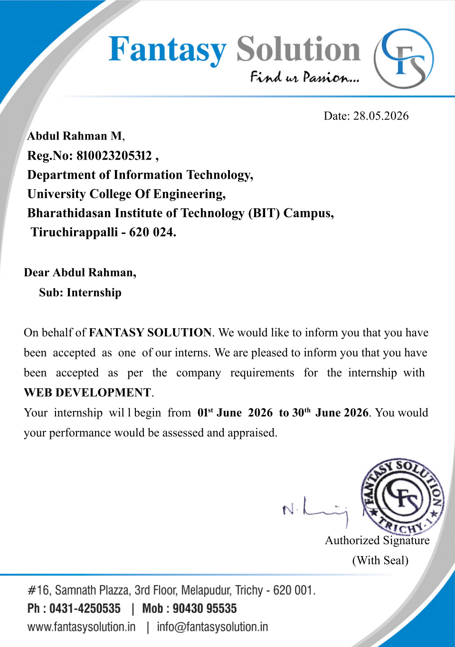
CERTIFICATE OF COMPLETION OF INTERNSHIP
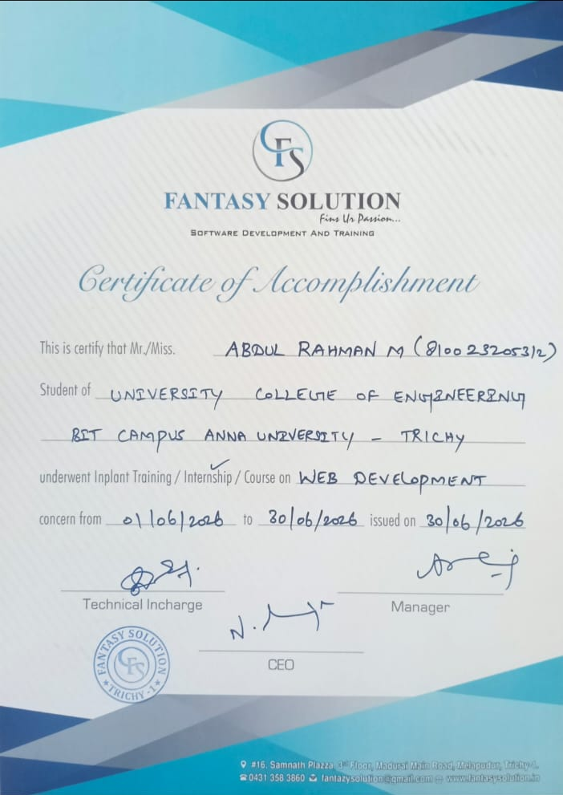
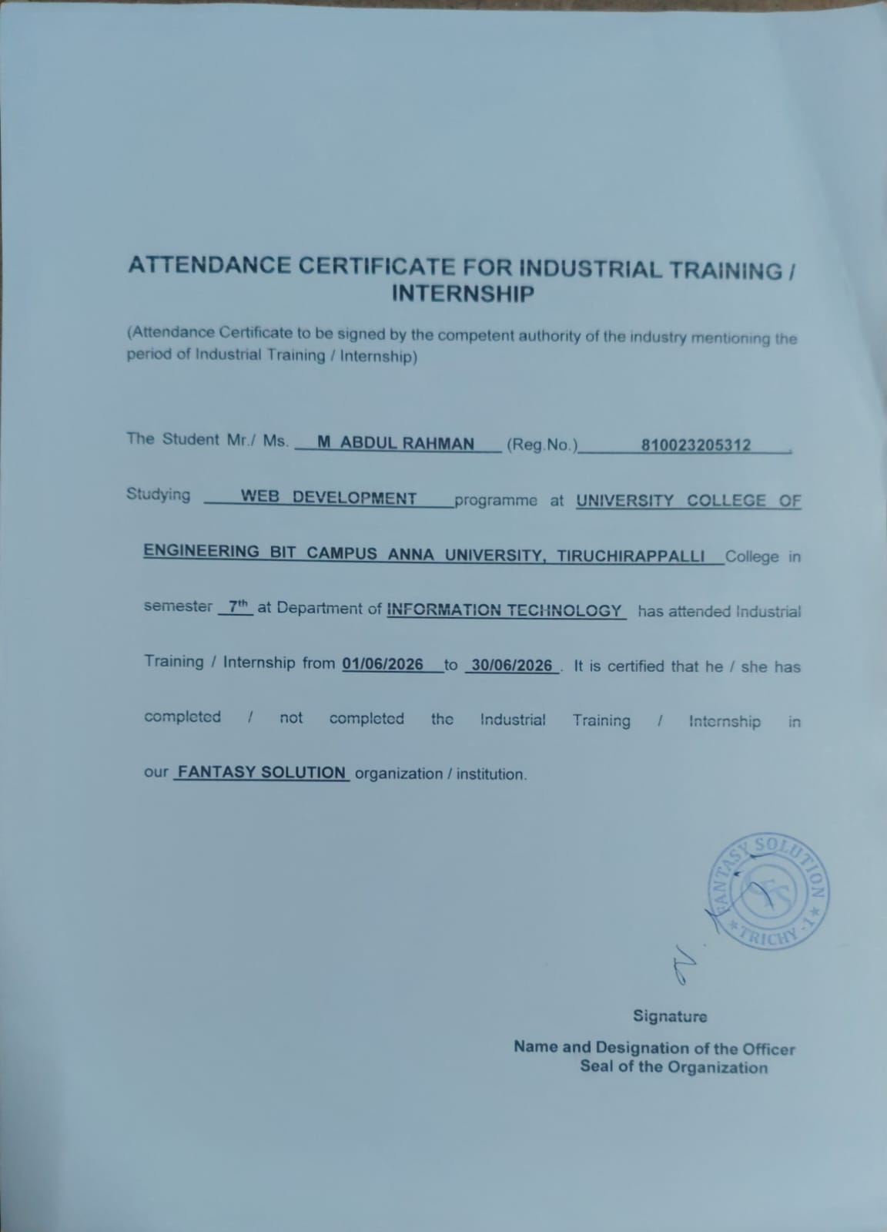
COPY OF ATTENDANCE
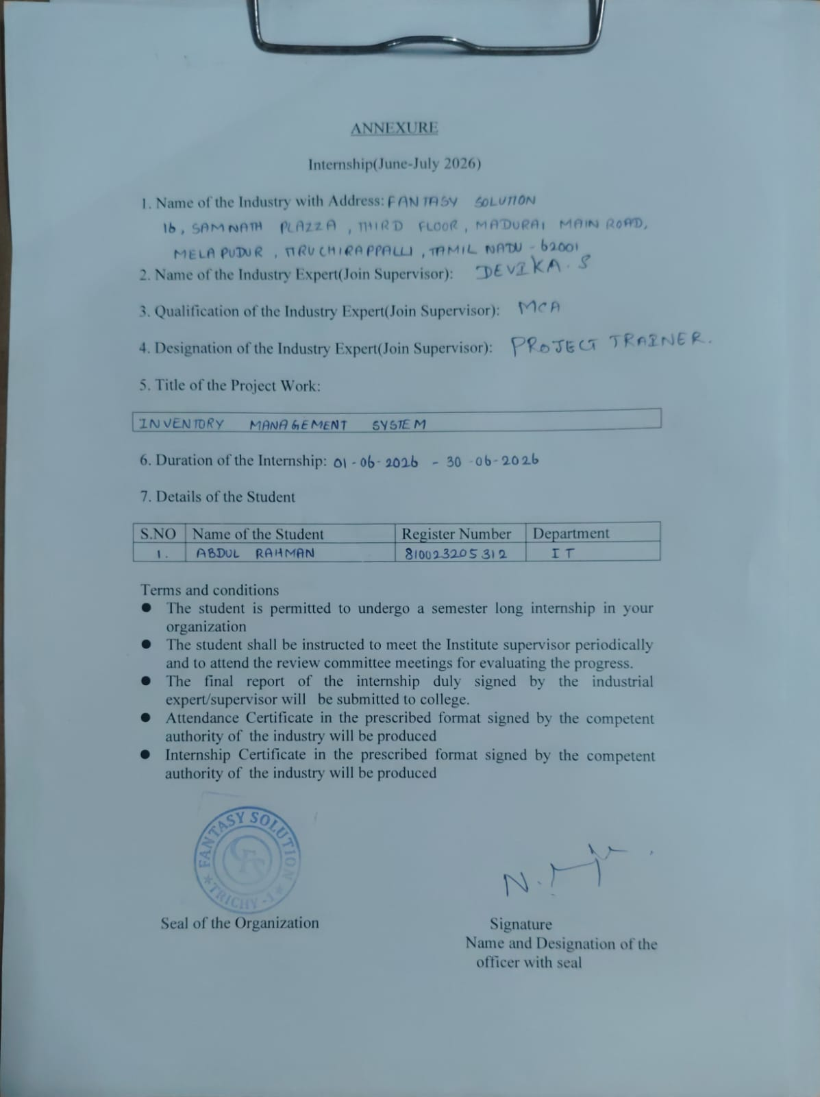
ANNEXURE

